**Data Analyst in Power BI Data-Camp 2025**

**Section 8: Intermediate Data Modelling in Power BI**

**Date Dime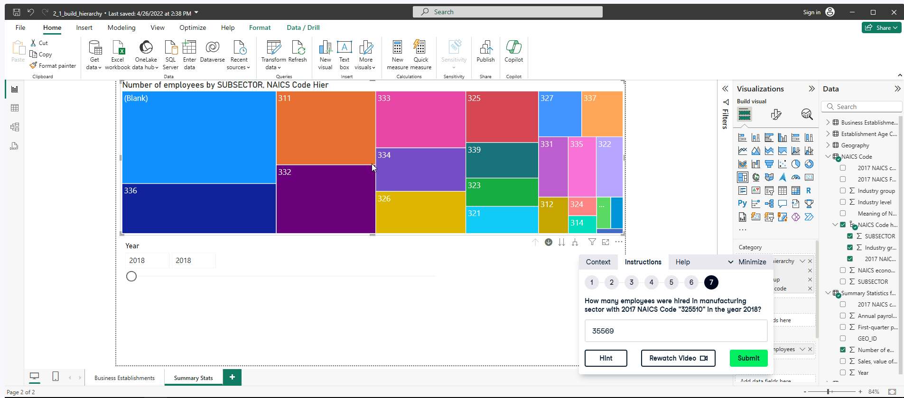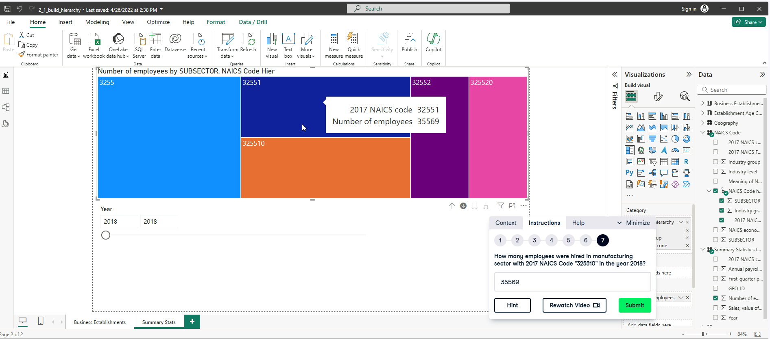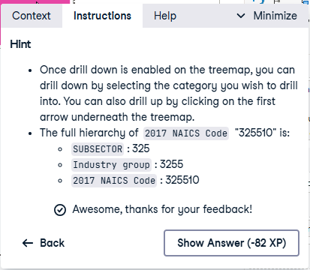nsions and Relationships**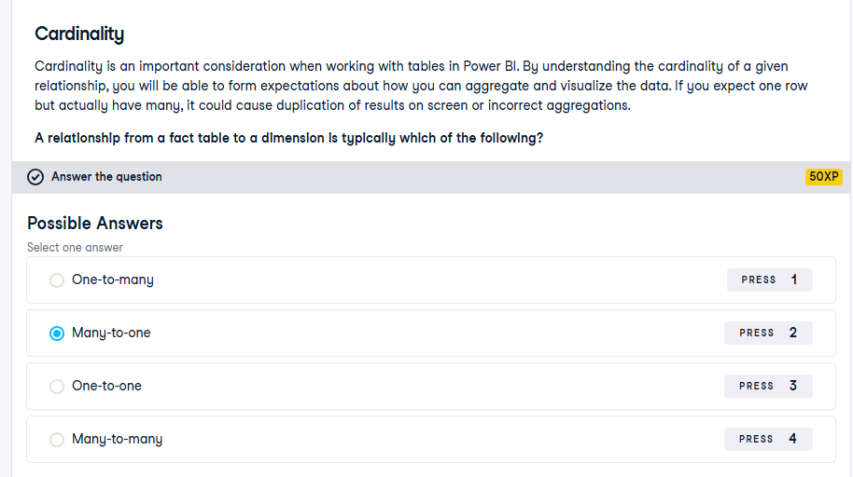

**Exercise 1.1**

Complete the following DAX syntax to create the Year table, which should contain a single column Year, with years ranging from 1961 to today’s year.

**Format:**

--- = // name of the table

DISTINCT ( // only keeps the unique rows

SELECTCOLUMNS ( // returns a table and creates new column based on expression

____ (DATE (___), ___) , // creates data range between 1961-01-01 and today

“___”, YEAR([]) // creates “Year” column, extracting the years only

) )

**Solution:**

YEAR = // name of the table

DISTINCT ( // only keeps the unique rows

SELECTCOLUMNS ( // returns a table and creates new column based on expression

CALENDAR(DATE (1961,1,1), TODAY() ) , // creates data range between 1961-01-01 and today

“Year”, YEAR([Date]) // creates “Year” column, extracting the years only

) )

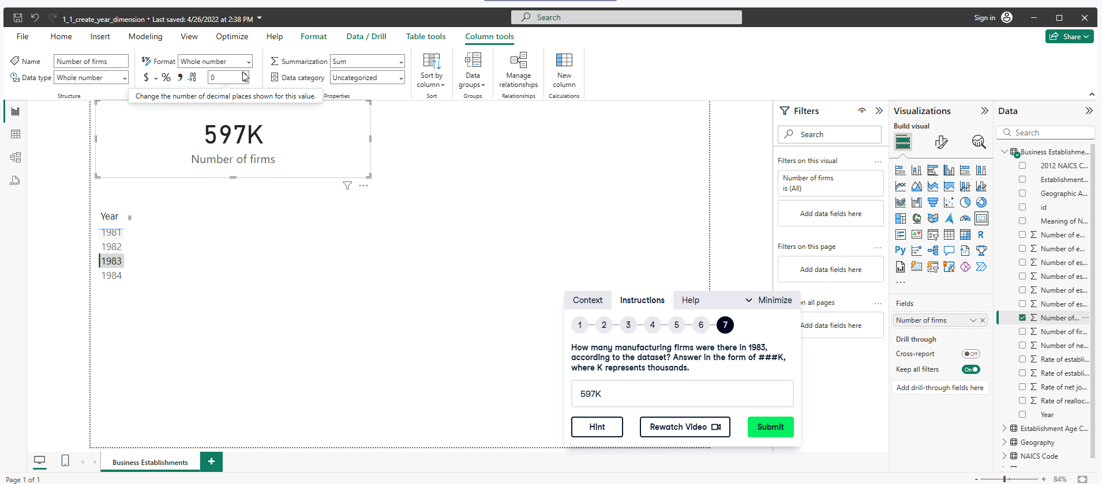

**Exercise 1.2**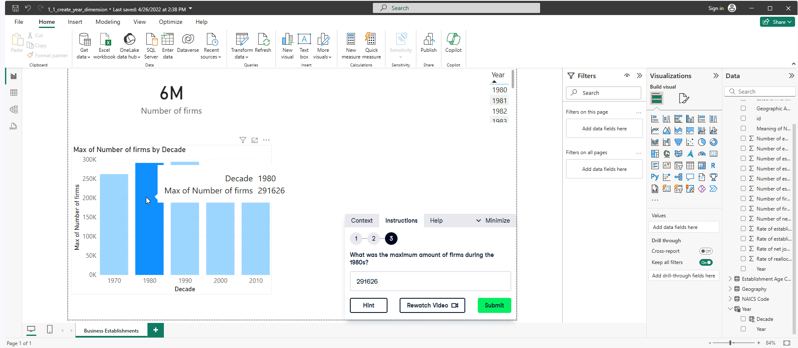

**Exercise 1.3**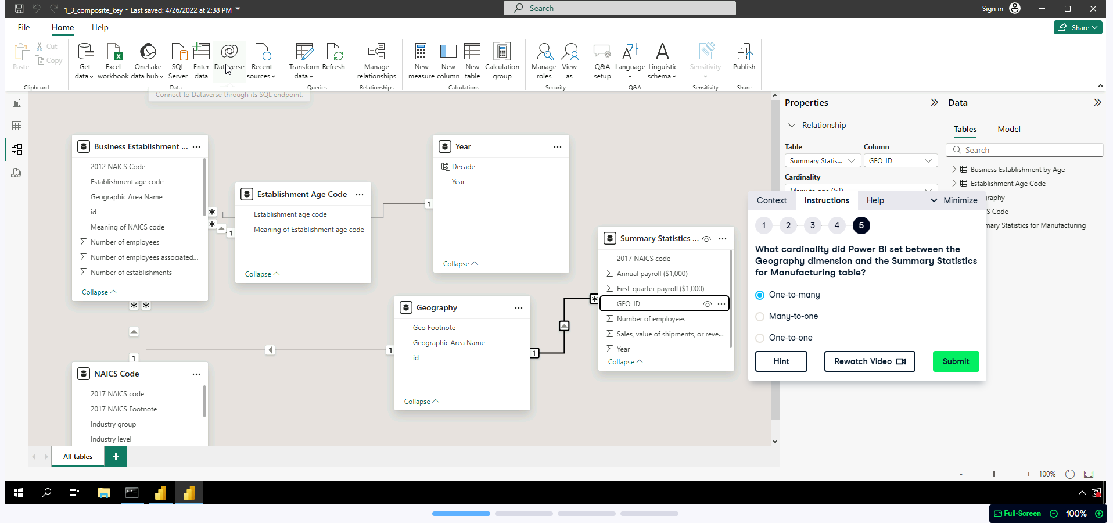

**Granularity, Measures, and Hierarchies**

**Exercise 2.1**

**Exercise 2.2**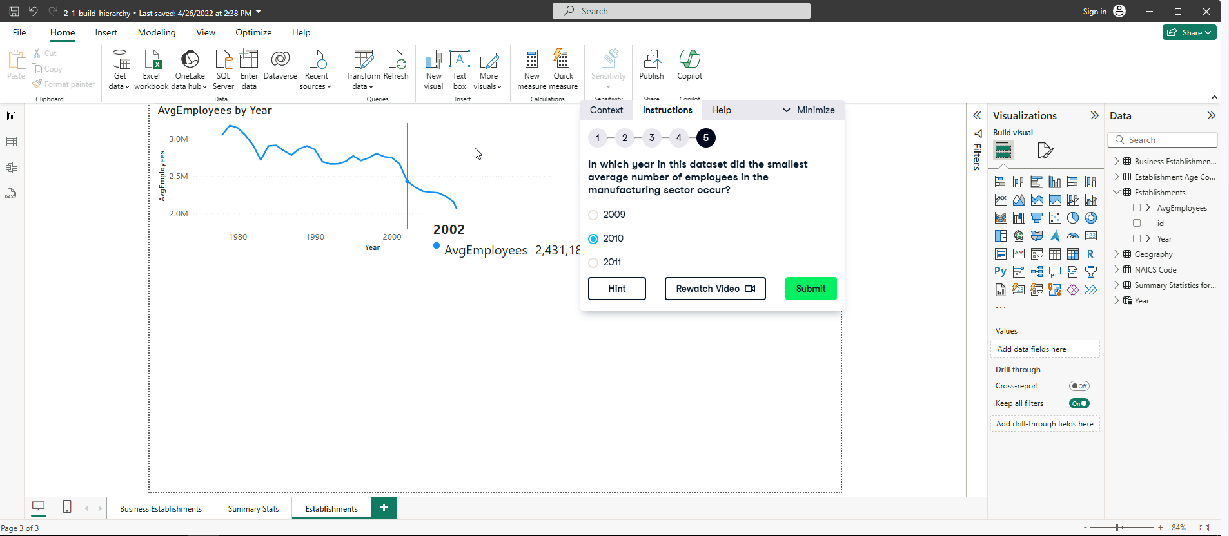

**Exercise 2.3**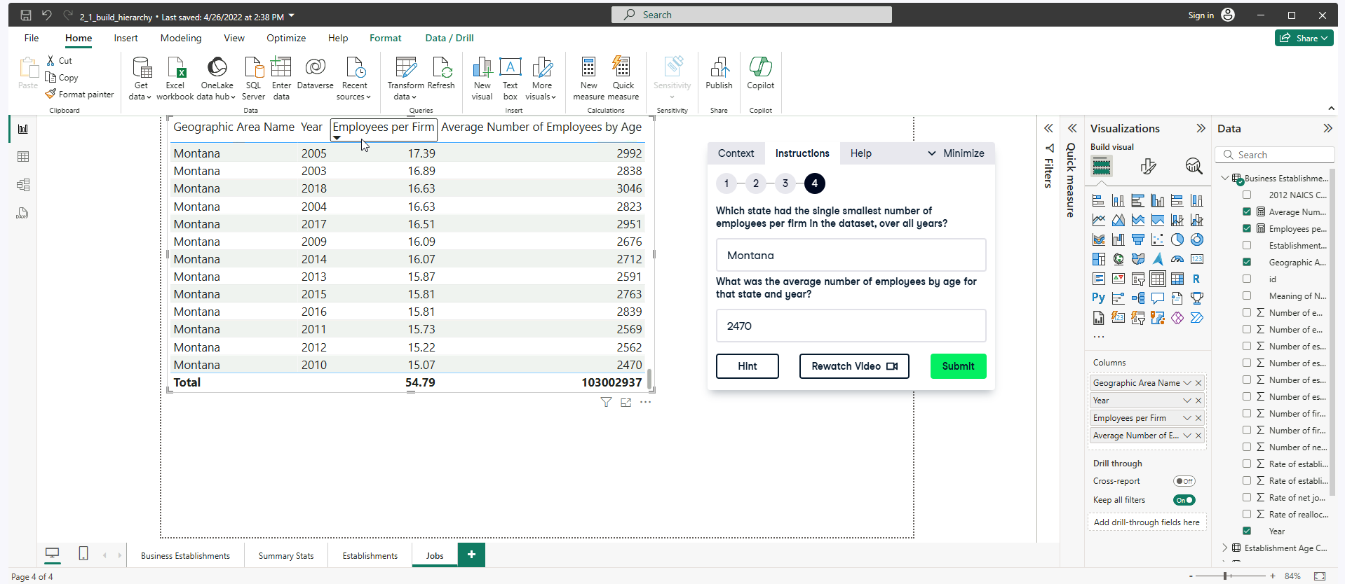

NOTE: ASKING FOR THE LEAST VALUE FOR THE SECOND QUESTION

**Advanced Data Modelling** 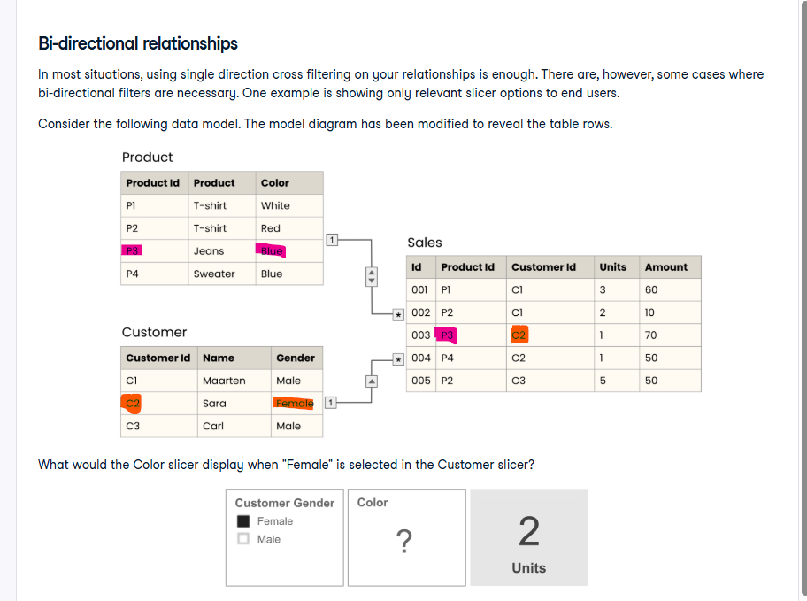

Answer: Blue

**

**Exercise 3.2**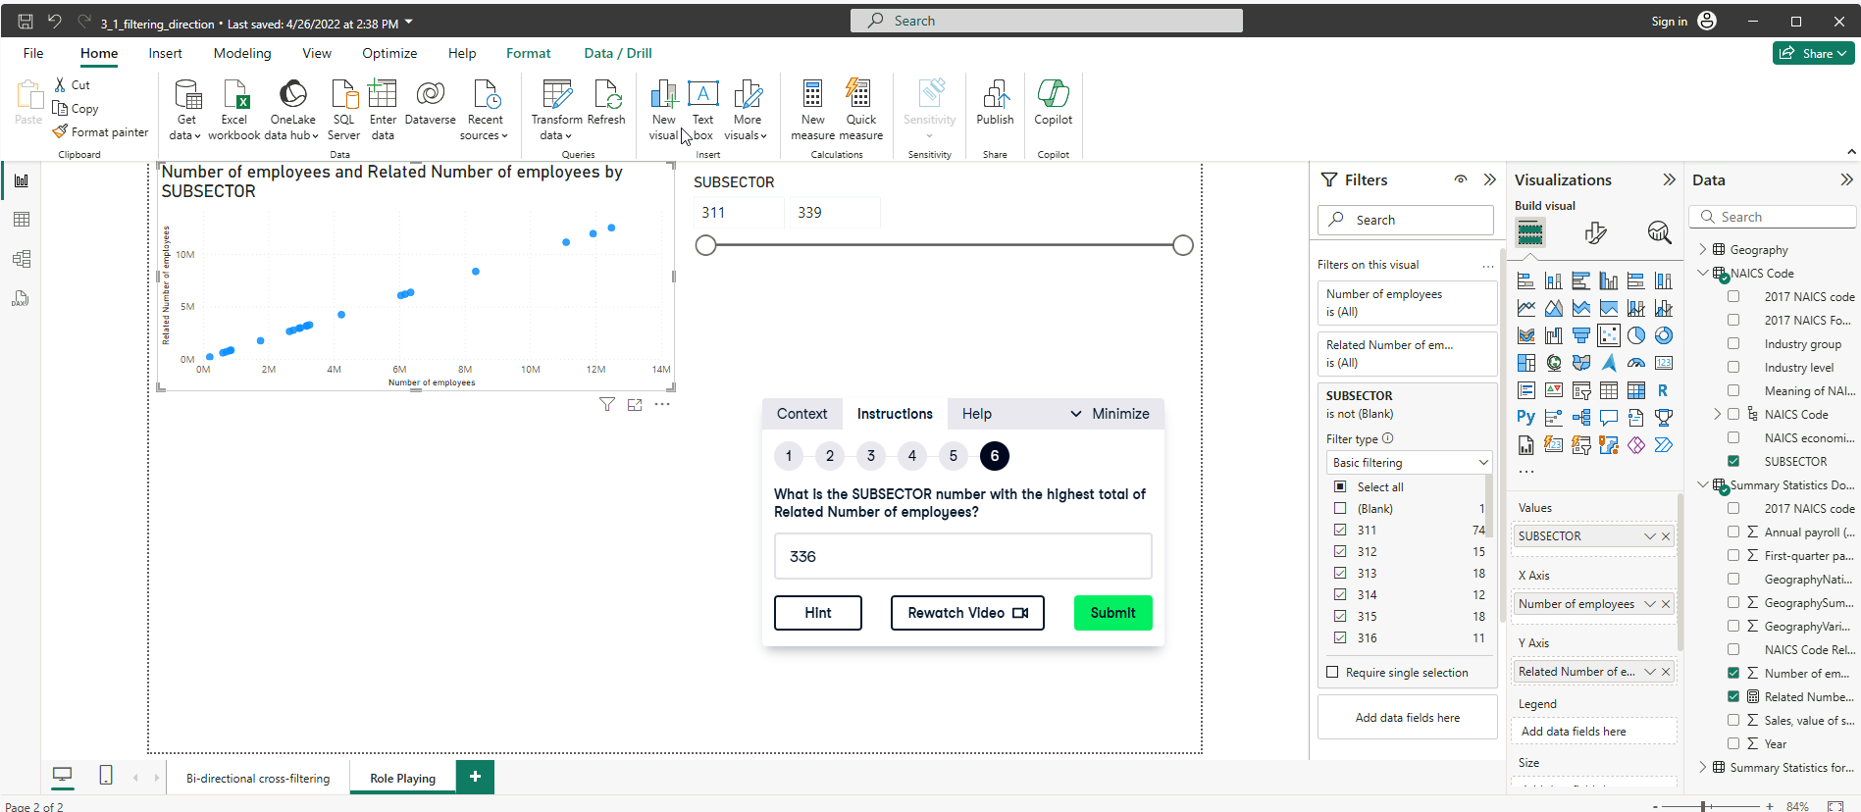

Fix the mistake from Step 3. 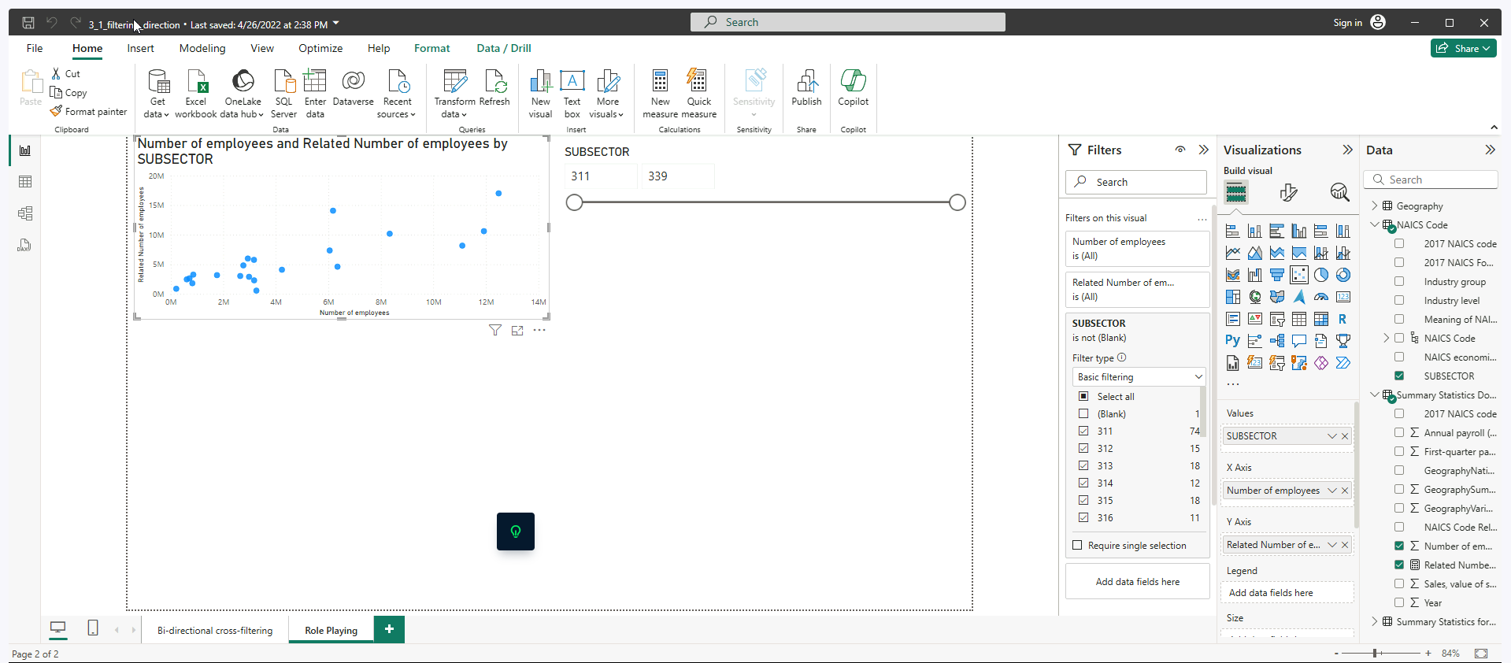

**Identifying Performance Problems**

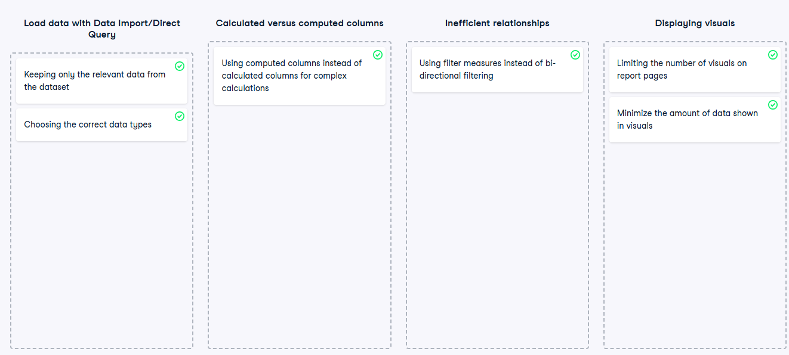

**Exercise 4.1**

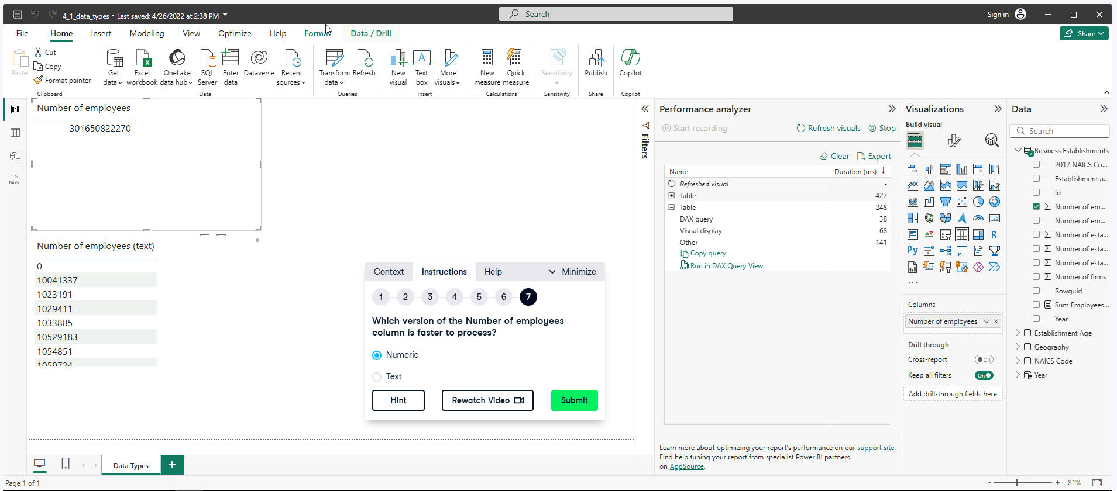

**Exercise 4.2**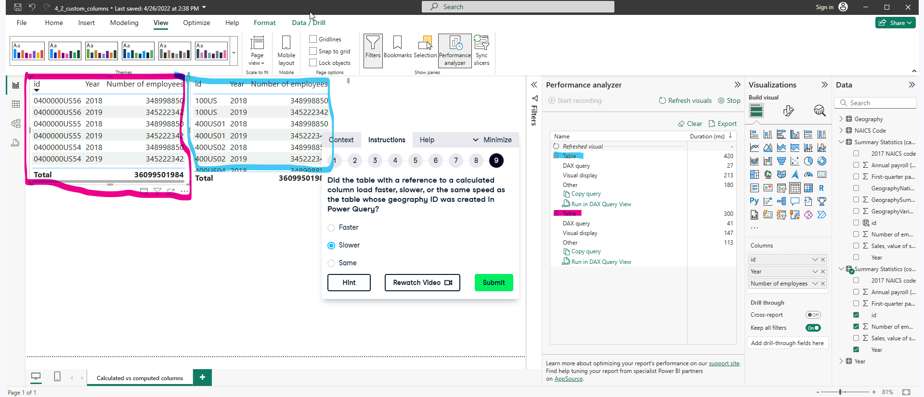

**Exercise 4.3**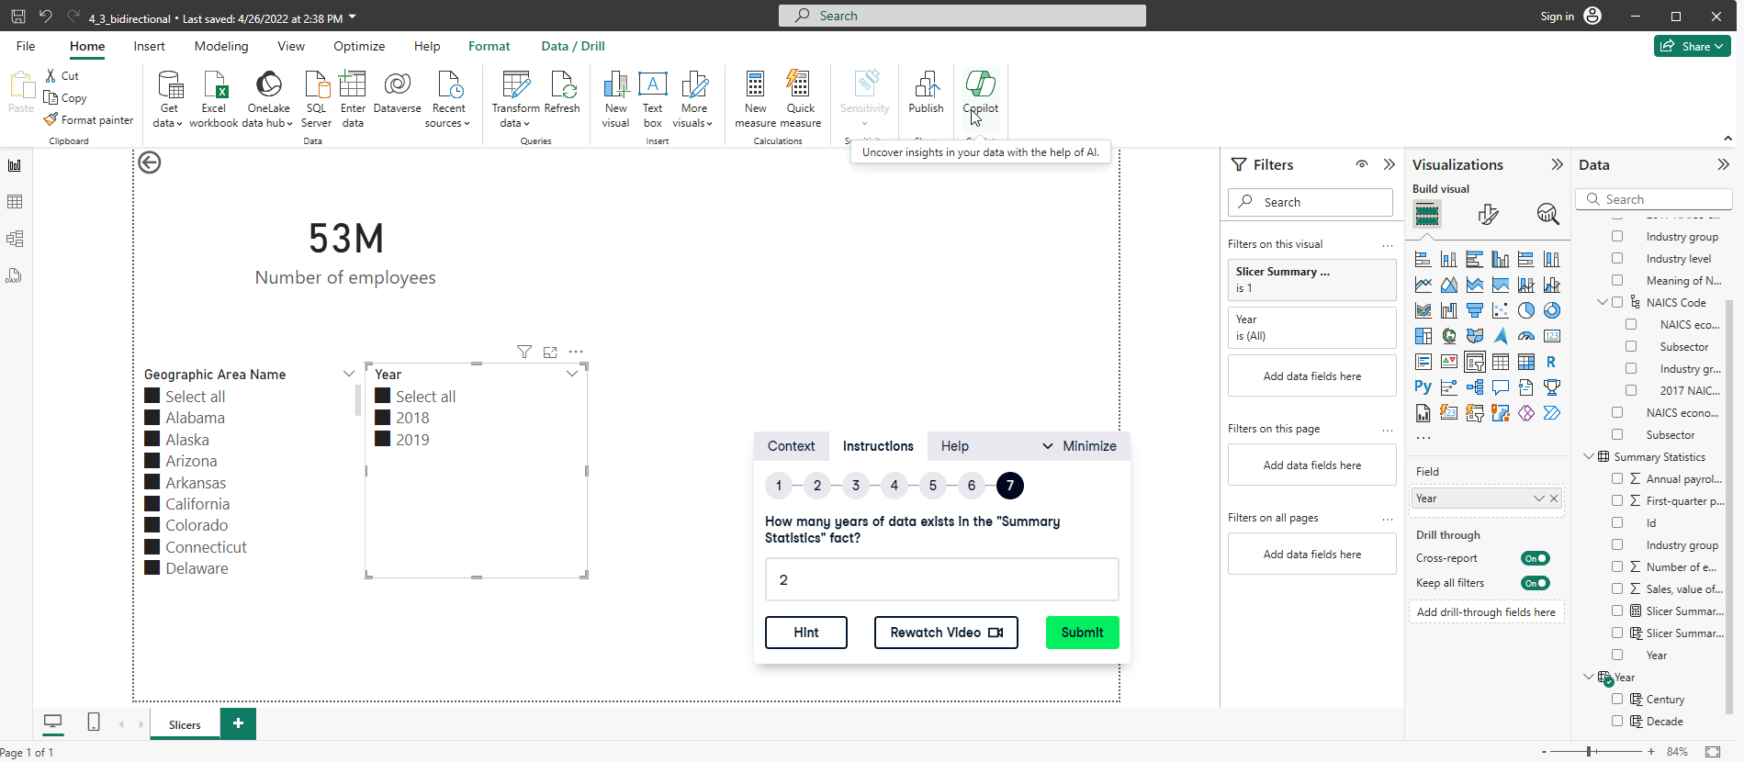

Create a new measure called Slicer Summary Stats

*Slicer Summary Stats = INT (NOT ISEMPTY(‘Summary Stats’)) returns values 1 if true, 0 is false.*

Add this Slicer Summary Stats into the Year filter.